**Creating System Title Logo for Comic Book Theme**

Requirements:

* GIMP (or Photoshop)
* Shaka-Pow Font(s) Installed
* TMNTturtlguy’s Dot Matrix Files

Mistakes you will make:

* You accidentally drew something on the wrong layer
* You forgot to deselect a region and the rendered product does not look right
* You forgot to inverse your selection when needed
* You stroke the Selection and not the Path
* Your Layers are out of order
* You left some Layer’s view enabled or disabled

Tips & Tricks:

* If you are new to GIMP and want to know where some tool is in GIMP, Google is your friend.
* Best way to learn is to experiment, you might discover something cool.
* There is always a different way to do the same thing in GIMP and Photoshop
* Undo (Ctrl-Z) is your best friend
* In this guide, if you pay attention to the little icons (next to the options that are selected) you can find them elsewhere in the program and they do the exact same thing.
  + For Example, most of the Layer’s options are near the bottom right of the screen.



**Setup Canvas**

1. Install the latest version of GIMP
2. Open GIMP
3. Select File > New (Ctrl+N)

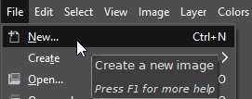

1. Create a Canvas size with a Width of 8” and Height of 3” (Make it bigger if needed)

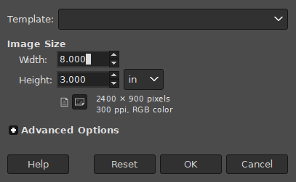

1. Create a blank transparent layer and delete the solid color layer that was created by default. You should be left with a gray checkered canvas.





1. Setup Canvas is Complete

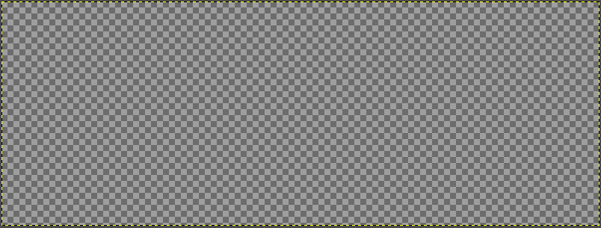

**Creating Text Layer**

1. Select the Text Tool

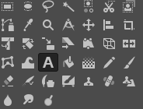

1. Set Font to “Shaka Pow”, Font Size to “150” “pt”, Hinting to “Full”, & Justify set to Centered. Color of your choice (For this example I will be using gray).

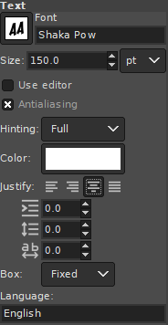

1. With the Text Tool select the entire canvas and type the name of the collection or system you wish to create. **NOTE**: This will create a new Layer, labeled with whatever you typed.

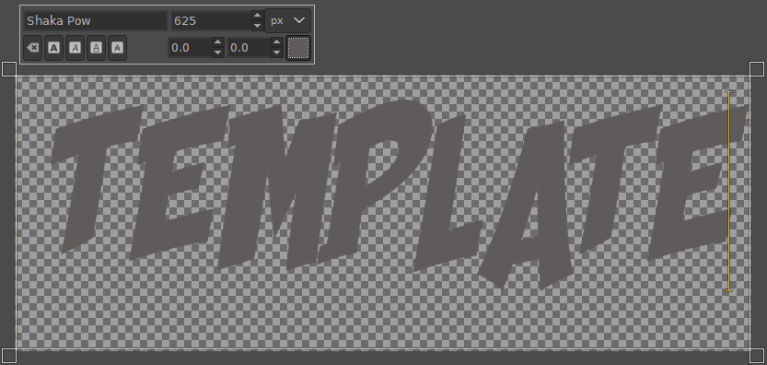

1. Select the Text you just typed by clicking & dragging to highlight each letter. It will look like each letter is in a yellow box.

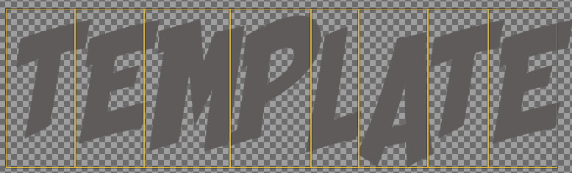

1. Now we will adjust the “kerning”. While everything is selected in the yellow boxes change the right box’s value from 0.0 to -22.0 and press enter. The Letters should move closer together, and the yellow boxes will start to overlap.

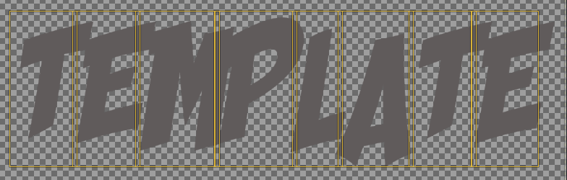

1. At this point it will vary from case to case, and be an artistic choice for some, but you may have to adjust some letter’s Kerning and Baselines individually. In all of TMNTturtlguy’s examples he always has each letter touching the other. In my example I will need to adjust the “T” at the end and the “L” until they are just barely touching its neighbors. Also, the “A” is hanging lower than the others. This is normal but I want it to be more inline so I will adjust its baseline upwards. **NOTE**: Experiment and find what works for you.

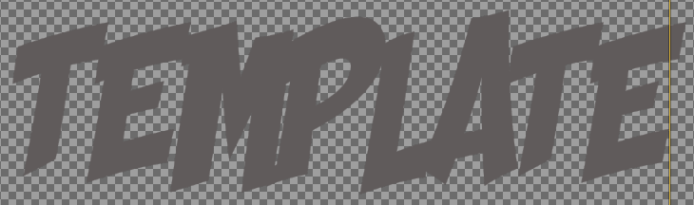

1. **WARNING**: Once you have set everything in place the way you like it, the next steps will be permanent. If you wish to adjust in the future, you will have to go back and redo your work.

**HIGHLY RECOMMEND**: You use the “Move Tool” to center the text in the canvas as this time.

1. Make a Duplicate of your Text Layer. I rename the New Layer “Text – Image” As we will be turning it into a true image and not be able to edit the text anymore.



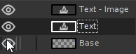

1. Right-Click on the “Text – Image” Layer and Select “Discard Text Information”. This makes the Text no longer editable (Essentially this Rasterizes the Text)



**Creating the Stencil Layer**

1. Go back and select the original “Text” Layer and make another duplicate. This time name it something like “Text – Stencil” Since this duplicate is still editable select every other letter and change its color. I used black in my example.

**NOTE**: You may have to disable some of your layer’s views as we are now getting to the point where overlaps or Layer order can cause some confusion.

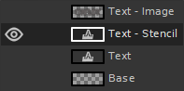

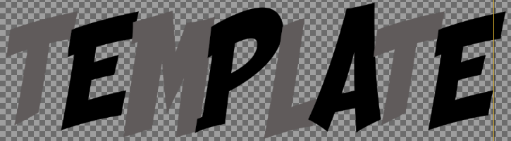

While still on the “Text – Stencil” Layer select and use the “Fuzzy Select Tool” (aka. the wand) to select each letter by holding Shift while selecting them all.

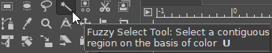

1. While every letter is selected right-click within a letter and choose “Select > Shrink” and choose 6 px. (Feel free to choose more or less)

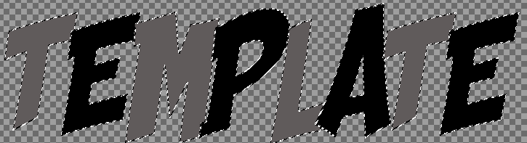

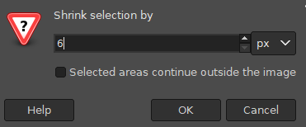



1. Then press the Delete Button on your keyboard, and then choose “Select > None”. You should have deleted the inner section of the text. Should look something like this.

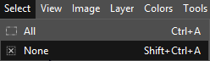

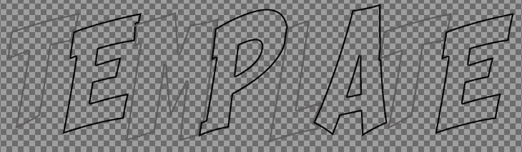

**Creating the Stroke Layers**

1. Create 3 New Blank Layers.

Name each one “Stroke – Color”, “Stroke – Black”, “Stroke – White”.

Be sure to stack the layers in the following order with views turned off:

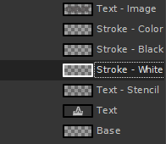

1. **IMPORTANT**: Go back to your Text Layer and Highlight the text again with the “Text Tool” **NOTE**: You will need to turn the view back on for the Text Layer.

Right-Click the highlight text and select “Path from Text”

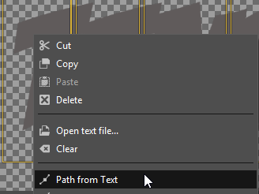

1. On the right side of your screen you can select the “Paths” Tab. It is kind of small. I highlighted it in red here for you.

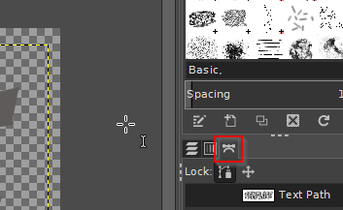

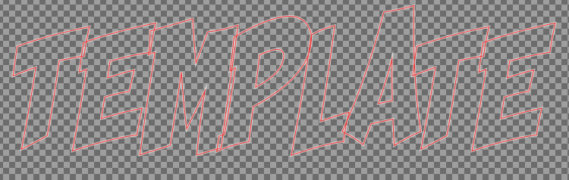

1. Rename the Path something like “Text Path” and turn it’s view on. A red or blue outline should appear on your canvas showing the path.



1. Go back to your Layers Tab and turn off all Views, except for “Stroke - White”, and then select the “Stroke – White” Layer. You should only see the Path Outline of the Text.

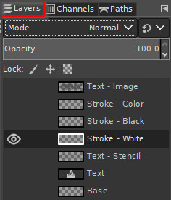

1. 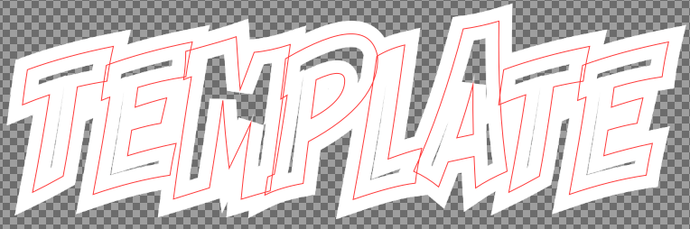**NOTE**: Be sure you are on the “Stroke – White” Layer before continuing, have its view turned on, **AND** that you have selected White as your primary use Color.

Go back to your “Paths” Tab and Right-Click your “Text Path” Select “Stroke Path...”

Be sure to select “Stroke line” Solid color with Antialiasing. Line width “21” “pt”.

Under Line Style, the Cap Style should be “Butt” and the Join Style should be “Miter”

**VERY IMPORTANT**: Miter limit should be 4.0

The final result should look something like the following. Be sure the edges are pointy not curved in any fashion.

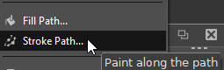

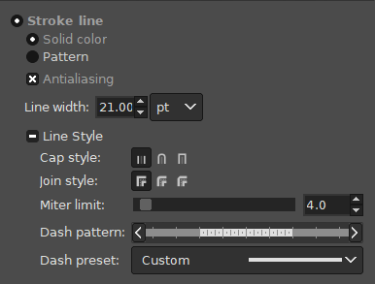

1. Repeat Step 6 above for the Black and Color Layers respectively. With the only change being the color, you use to stroke with, and the Line Width.

Black Line Width should be “14.27”

Color Line Width should be “1.00” or “2.00” It’s artistic choice for what color this should be. In my case I am using the same gray color as the letters.

**NOTE**: Be sure you are putting them all on their respective layers

Black Stroke

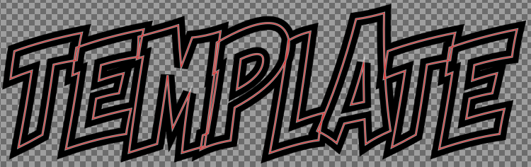

Color Stroke

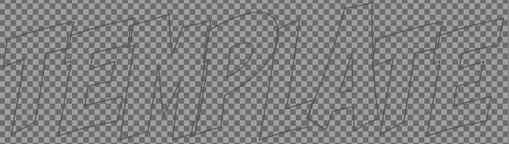

1. You can turn off the View for the “Text Path” as you don’t need it, and it was only enabled as a visual aid. In the future you don’t even need to turn it on.
2. Turn off all the Layer Views as well.
3. Duplicate the “Stroke – White” Layer and name it “Bgrd Shadow Color” Turn its view on and place the Layer under your “Stroke – White” Layer. Like the following:

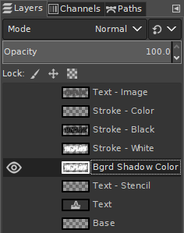

1. Fill (using the Bucket Fill Tool) the White on the “Bgrd Shadow Color” Layer with the same Color of your choice from the “Stroke – Color” Layer (Step 7). Since I did not choose one, I left it gray.

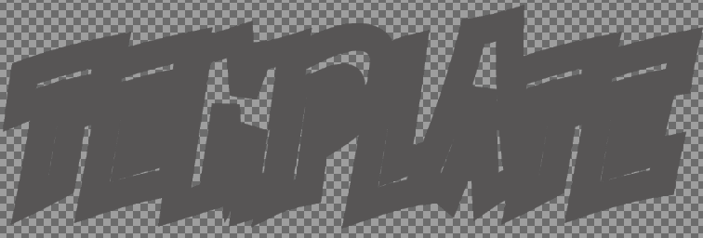

1. Using the “Move Tool” slightly move the “Bgrd Shadow Color” Layer down a few pixels. You can easily do this by clicking on the image in the canvas and using your arrow keys on your keyboard to move it down a little. **BE SURE** “Move the active layer” is selected for the “Move Tool”

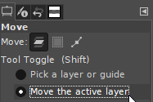

1. Go and turn on the View for “Stroke – White” Layer. However stay selected on the “Bgrd Shadow Color” Layer. The Color should be peaking out from behind the white.

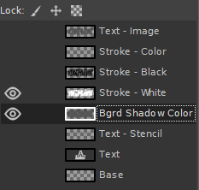

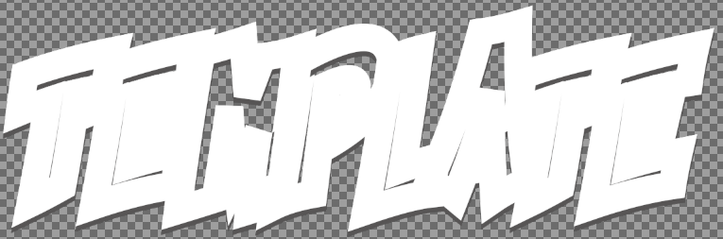

1. Zoom in (Hold Ctrl and use scroll wheel on your mouse) to an edge down at the bottom. I am zooming in towards the “T” on the far left. Since you are still selected on the “Bgrd Shadow Color” Layer only it should move when you use the “Move Tool”

Line Up the Edges so it makes a nice straight point.

**Before** **After**

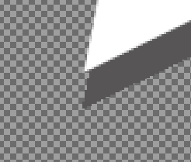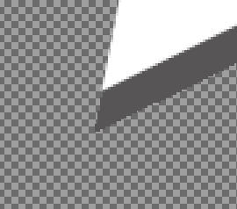

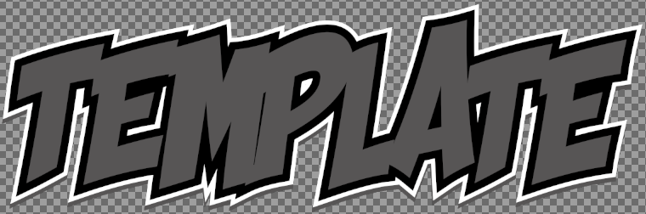**Progress Report**

1. Zoom back out and if you turn on all the following layers it should look something like this:

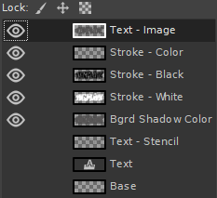

**Creating the Dot Matrix Layer**

1. Turn all Layer Views off except for the “Text – Image” Layer
2. Import by dragging and dropping one of TMNTturlguy’s Dot Matrix files into your Canvas.

If it prompts for anything just accept the defaults

1. Rename the Layer “Dot Matrix” and Place it on top of the Layer Stack. Like such:

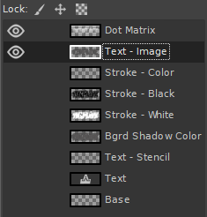

1. Using the “Move Tool” position the “Dot Matrix” Layer until it covers the letters the way you want it to.

I normally try to get the small dots at the very bottom like such (Red box is just emphasizing the small dots at the bottom of each letter):

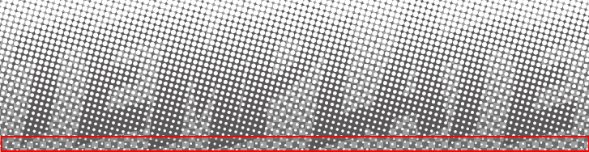

1. **IMPORTANT**: Right-Click the “Text – Image” Layer and select the option “Alpha to Selection” This will select everything in the “Text – Image” Layer.



1. **IMPORTANT**: Go to Select and choose “Invert”

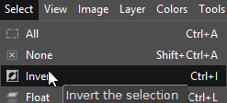

1. 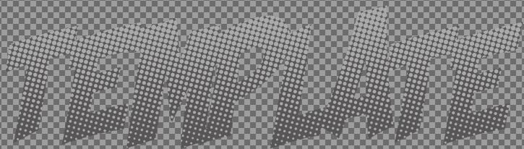**IMPORTANT**: You should still be on the “Dot Matrix” Layer. If not select it now.
2. Press Delete on your keyboard. And then choose Select > None (Shift+Ctrl+A)It should look like the following.

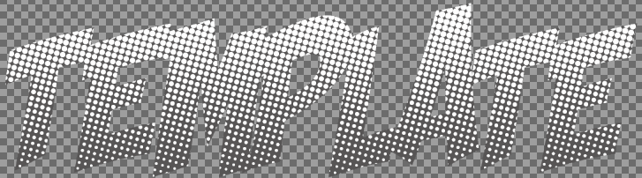

1. The Dot Matrix itself is pretty noticeable so to change that and make it blend better with the letters you can change the opacity. It is artistic choice for how much or how little to choose. In this example I went with 33%.

**NOTE**: Be sure you are still on the “Dot Matrix” Layer when you change the opacity. Otherwise you might be changing something else you did not intend to change. **ALSO** Be sure you have nothing selected.

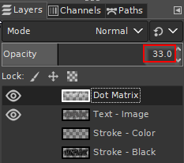

**Creating the Gradient Layer**

1. Create a New Blank Layer and name it “Gradient” and place it on top. Keep its view on.

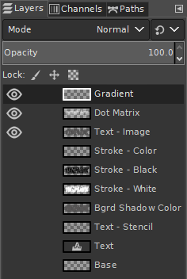

1. Select the “Gradient” Layer, and re-select the text from the “Text – Image” Layer like we did in Step 5 of the “Dot Matrix” using the “Alpha to Selection”
2. **IMPORTANT**: You should still be on the “Gradient” Layer if not select it now.
3. Select the “Gradient Tool”

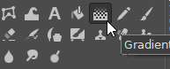

1. Change the Gradient from its Default to “FG to Transparent”

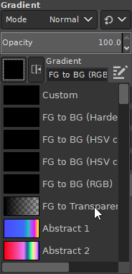

1. Before we apply the Gradient be sure to select the **SAME** color as the Text.

However, it can be whatever you want it to be. It is an artistic choice.

Since my Text color is gray, I went with gray.

1. **IMPORTANT**: Be sure you still only have the Text-Image selected as your active selection. Otherwise the entire canvas will have the gradient on it. We only want the gradient applied to the text area.

**Before**

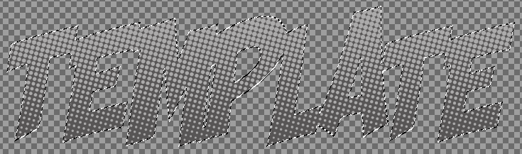

**After** (NOTE: I applied from Bottom to the Top as indicated by the Yellow and White cursors)

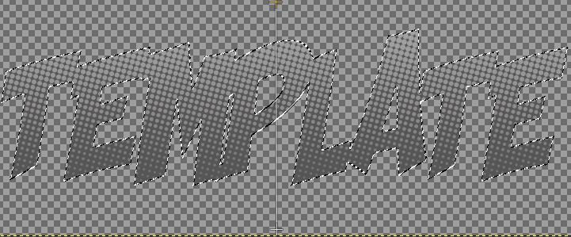

**IMPORTANT**: Be sure you press enter and the Cursors should disappear. Otherwise you might accidentally apply the gradient to something else.

1. 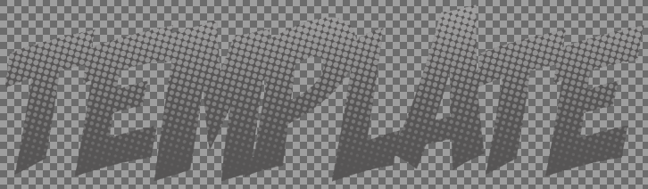Optionally you can adjust the gradient offset to get it to blend in more. I set mine to 20 in this example:

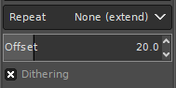

**Add in the Stencil Layer**

1. It’s now time to use that stencil layer we made way back at the beginning of this tutorial.
2. Turn off all layers except for the “Text – Stencil” Layer
3. Select everything in the “Text – Stencil” using the “Alpha to Selection” option.
4. **IMPORTANT**: Be sure to use the same Color that use you used in “Stroke – Color” Layer.
5. Delete the entire contents of what was selected by the “Alpha to Selection” by pressing the delete key on your keyboard. Then use the “Bucket Fill Tool” to fill in the selection with the color you used for the “Stroke – Color” Layer.
6. Deselect your selection and it should look something like this, all one color:

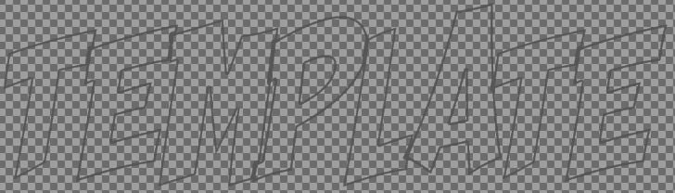

1. Place the “Text – Stencil” Layer on top of the “Gradient” Layer.

Turn on the Views for the Stencil, Gradient, Dot Matrix, and Text – Image to see the result.

**Before Stencil**

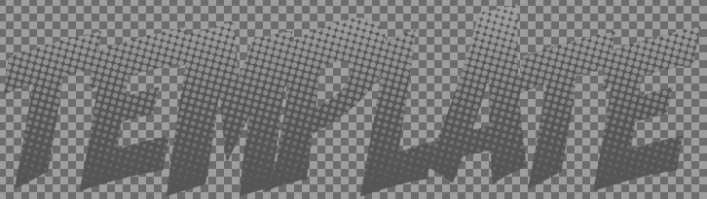

**After Stencil**

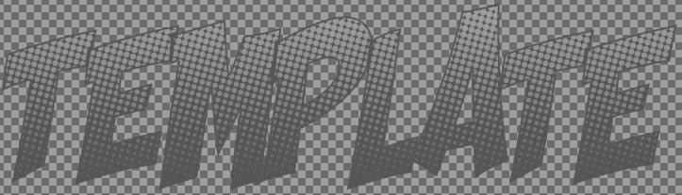

**Progress Report**

1. Turn on all the following Layer Views and check your work

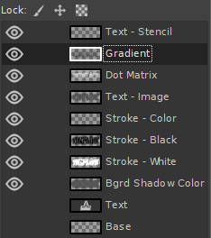

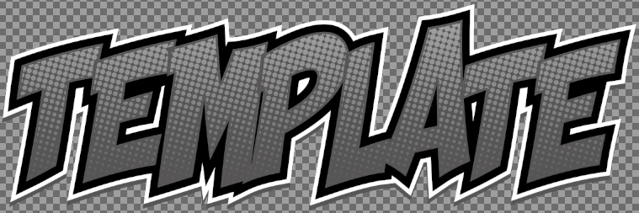

**Adding the Drop Shadow**

1. The last thing to do is to add the Drop Shadow.
2. Select the “Bgrd Shadow Color” Layer
3. Select Filters > Light and Shadow > Drop Shadow

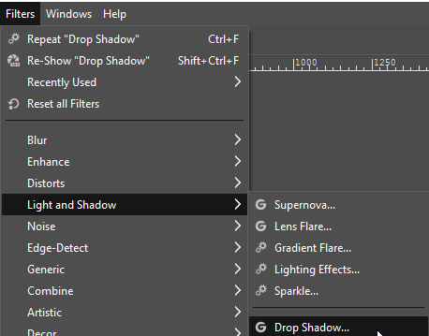

1. **NOTE**: we will add 4 Drop shadows in total. The Defaults are pretty good, feel free to experiment. I suggest the following (I only adjusted the Blur radius to 30):

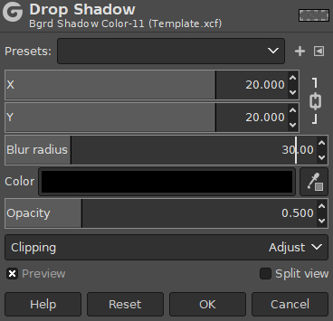

1. Do Drop Shadow 3 more times (4 in total) but change the X and Y to the following:
   1. X=20 Y=20 (Did it in Step 4)
   2. X=-20 Y=-20
   3. X=-20 Y=20
   4. X=20 Y=-20

**NOTE**: Each time you apply the shadow it will get darker. Experiment with different blur radius settings and opacity settings.

**Before Drop Shadow**



**After Drop Shadow**

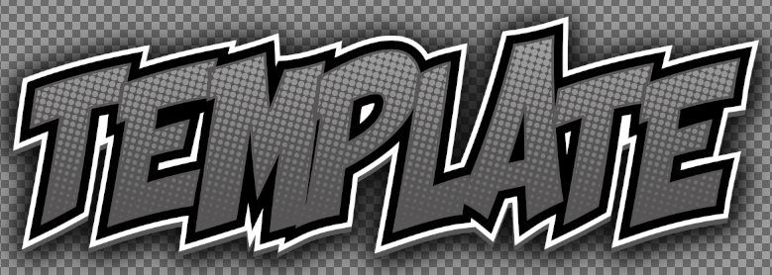

**Exporting to PNG**

1. Go to File > Export As and save the file as a PNG.

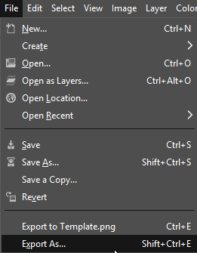

1. Leave everything as the default.

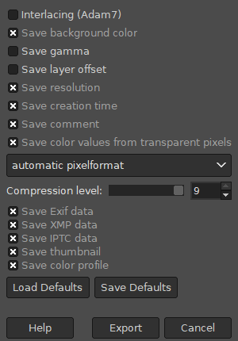

**Image Scaling**

1. If you plan to use your image on a low power device such as Raspberry Pi or Android phone. It can be possible that if an image is to high a resolution it can be problematic for the device.
2. **WARNING**: Before scaling an image down I recommend saving your work as another project file as if anything goes wrong you can go back to your original.
3. Go to Image > Scale Image”

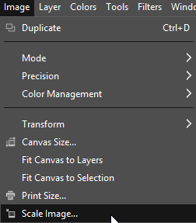

1. Select the dimensions you desire.

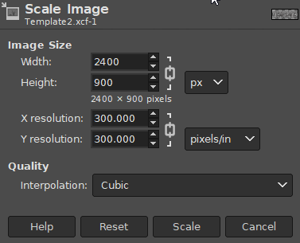

1. When we first started and created a canvas with 8” by 3” it created a 2400 x 900 pixel canvas. So what we can do is halve the resolution from 900p to 450p. Since they are locked together they will scale together as well. Here is a 900p Original, 450p Half and 225p Quarter variants.

**900p (695 KB)**

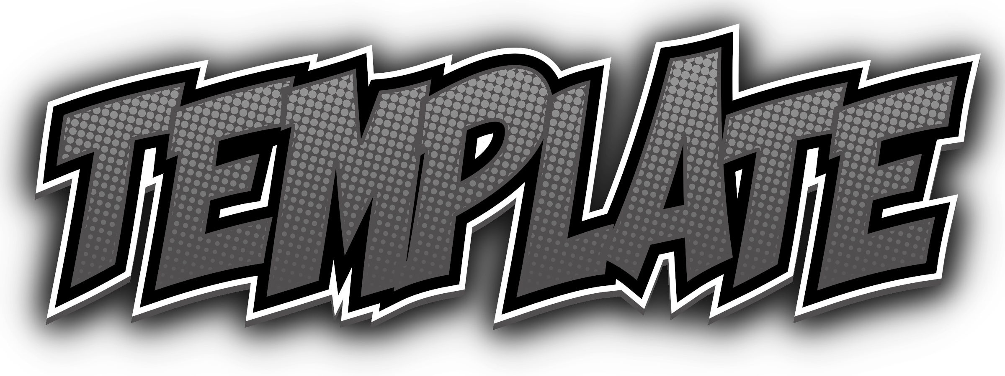

**450p (266 KB)**

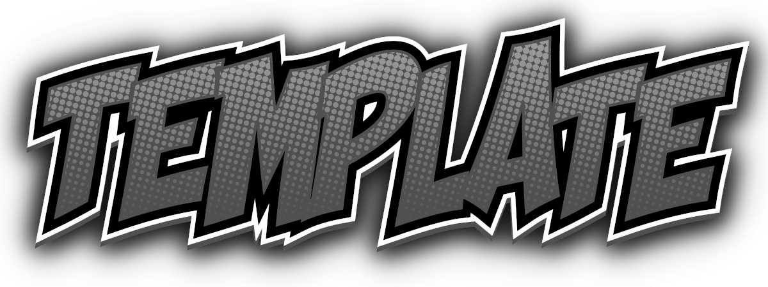

**225p (115 KB**)



Hope this Tutorial will help spark some creative collections and newer system themes.

After Thoughts:

Please experiment and try new things. This is just to be a guide to help get you comfortable creating a system image for the ComicBook Theme.